Lab 6.
Leader: Manny Cabaya
Members: Melinda Nipes
Kecel Dujali
Shine Tayogandaga
Isabel Ingrid Monarca
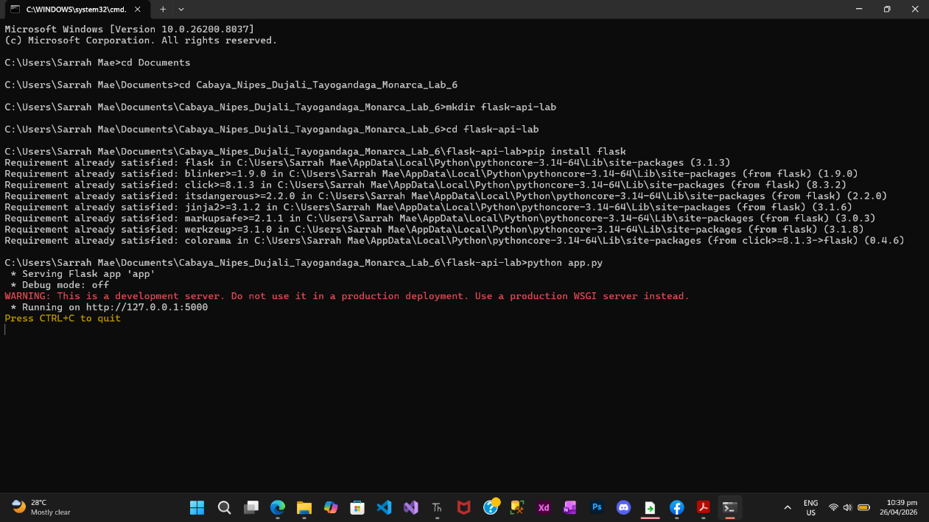

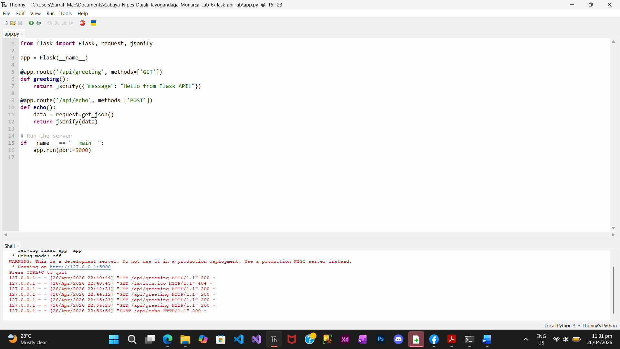
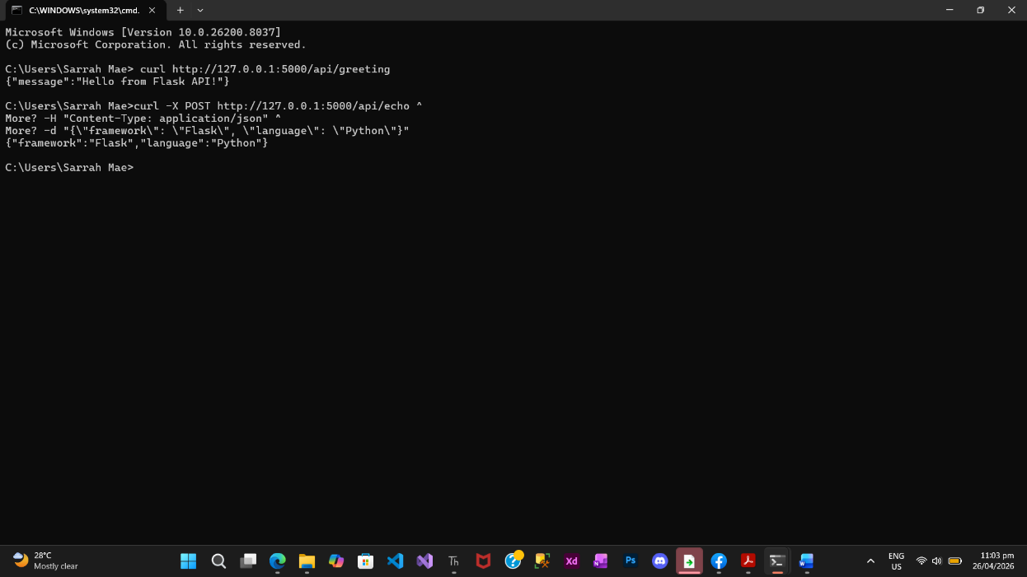

Lab Questions:
- Syntactic Sugar: In Express, you used app.get(). In Flask, you use @app.route(..., methods=['GET']). Which do you find more intuitive, and why?
- Flask’s @app.route(..., methods=['GET']) is more explicit because it clearly shows both the route and allowed methods in one place. However, Express’ app.get() is shorter and easier to read at first. Personally, Flask feels more organized, while Express feels simpler.
- The "Micro" Nature: Flask is called a "micro-framework." Based on your experience setting it up, how does it handle things like JSON parsing compared to Express?
- Flask is called a micro-framework because it provides only the essentials. For example, JSON parsing is done manually using request.get_json(), while in Express, middleware like express.json() handles it automatically. This means Flask gives more control but requires more setup.
- Cross-Language Abstraction: Even though the language changed (JavaScript to Python), did the Endpoint, Method, and Payload stay the same? What does this tell you about the "Standardized Contract" of HTTP?
- Yes, the Endpoint (/api/...), Method (GET/POST), and Payload (JSON) stayed the same. This shows that HTTP is a standardized contract that works across different programming languages. No matter the language, APIs follow the same rules for communication.

